

Computer Games Development

Project Report

Year IV

[Muhammad Danial Hakim Bin Nor Azman]

[C00253517]

[26/04/2023]

**DECLARATION**

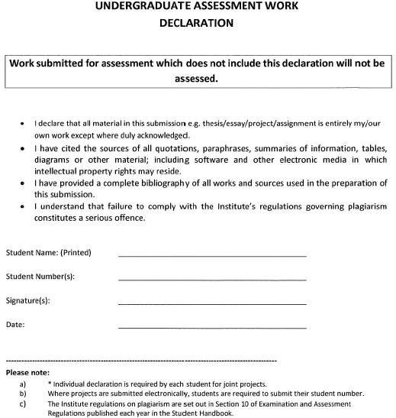

Muhammad Danial Hakim Nor Azman Azman

26/4/2023

Danial Nor Azman

C00253517

**Contents**

Acknowledgements 3

Project Abstract 3

Project Introduction and/or Research Question 3

Literature Review 5

Evaluation and Discussion 14

Conclusions 21

References 21

# Acknowledgements

I am appreciative of my supervisor, Oisin Cawley, for his knowledgeable advice and assistance with my research project. His helpful recommendations on choosing a research paper, setting specific goals, and game accessibility concepts greatly helped my work. Oisin Cawley's regular meetings and constructive criticism have helped my project go more smoothly, and I value his commitment to my academic achievement.

# Project Abstract

This research paper studies the difficulties experienced by people with disabilities who play video games and the importance of accessibility. It explores the difficulties that disabled gamers encounter and reviews existing research paper done by others on game accessibility. The method used in this research paper involved creating a game with accessibility features in mind, conducting playtesting sessions with participants, and collecting feedback through questionnaires. The aim of this research is to investigate the impact of existing accessibility features on disabled gamers.

# Project Introduction and/or Research Question

**Disability in gaming**.

Understanding the impact of disability on gaming experiences is crucial in today's inclusive gaming landscape, where accessibility and inclusivity are gaining increasing attention. Disability is a broad term and there is multiple form of disability, the four that will be mention in this research paper are intellectual, physical, sensory, and mental illness. While mental illness might impair a person's emotional state and behaviours, intellectual disability involves difficulties with speech and memory. Physical disability focuses on long-term impairments, such as being born without a limp or losing bodily parts in an accident. Senses including sight, hearing, and spatial awareness are all impacted by sensory impairments. Due to their limits, people with certain disabilities find it more difficult to perform daily tasks than non-disabled people. This can cause stress to accumulate, and like other gamers, they use games to unwind and let their stress out.

**2 Types of gamers**

Two distinct sorts of players are well known in the gaming world. Hardcore gamers are the first category. This kind of player plays the game for hours on end to thoroughly understand the multiplayer maps and find the best locations. Additionally, they would spend time studying and memorization the combo and attack pattern to maximise the damage output. They give their all to the game they are playing. In the gaming industry, they are typically the finest of the best. Some people even make a career out of gaming and participate in e-sports. E-sports is a type of video game competition in which professionals compete and are compensated for their victories. Most gamers fall into the next category, which are casual players. Casual gamers engage in the game for entertainment and to release tension and irritation. They play video games at their own pace and take their time to enjoy them. The outcome of the game is typically not important to them because it is not the primary reason they play.

**Challenges faced by disabled gamers**

Some disabled gamers are hardcore gamers that went on to be professional gamers regardless of their limitation. Mike "BrolyLegs" Begum would be one of the instances. Mike Begum plays with his face as a professional Street Fighter V player. Arthrogryposis, a congenital muscle disease, is his impairment and prevents him from using his hands to operate the controller (Silman, Sep 20, 2021).Mike overcome his impairments by using a custom controller that suits his needs. He would grip the controller with his chin and play the game using his tongue as a replacement for his thumb. Another professional gamer would be Ewok (Ferreiro, 2019). In addition to being recently employed by Faze, Ewok is a professional Fortnite player who was deaf from birth (Villanueva, 2019). Faze is a professional gaming organization that are regularly in some of the biggest gaming tournaments. In the battle royale game Fortnite, sound is crucial since it might reveal information like the location of an attack or the footsteps of an opponent. Ewok uses the sound visualization game accessibility feature, which provides a visual indicator to show where the sound is coming from onscreen, to compete with other players.

**Immersions and Enjoyment**

One of the most crucial components of a video game is immersion (Charlene Jennett a, 2008). Video game immersions offer the player the impression that they are transported into the game's environment, increasing their sense of identity with the character. This is made possible by cutting-edge graphics, well-planned stories, and excellent game flow. The player is kept engaged and committed to the game, which encourages them to play again. When they watched another player play the game online, several gamers experienced a sense of immersion. Streamers are the gamers who are watched online while playing video game. Streamers would add entertainment value to their streams by taking on challenges. These gamers typically excel at the games they are playing, accomplishing feats that many gamers are unable achieve. Due to their limitations, most disabled streamers would have to find alternative ways to play games. Martin, popularly known as 86hands, is one of the cases, who has received accolades for playing video games proficiently despite having a disability. Martin played the game by holding the Xbox controller between his jaw and a portion of his arm because he was born without hands (Kate, 2022).

There are more ways to enjoy playing video games now thanks to advancements in technology (Dario Maggiorini, 2019) and one of them is eye tracker. An eye tracker is a tool for monitoring eye movements and positions. To help other gamers understand where their focus should be when playing games and to help them enhance their understanding of the game, streamers utilize this in games to highlight their eye positions and how long their gaze is at different positions on the screen. Game sense refer to the ability to take in and process all the information necessary to make the optimal decision, including understanding where the enemy is and when to move to provide the player the best chance of winning the battle.

# Literature Review

**Video games and disability**

Gaming is one of the most well-liked pastimes out there and that there are over 3 billion players worldwide—nearly half of the world's population—comes as no surprise (Jovanovic, 2022). 20.5% of casual gamers had disabilities in 2008. This figure does not account for the professional gamers with a range of disabilities, which would bring the total up even higher (Eyeware Beam , 2022). Many computer interfaces and game controllers are designed with non-disabled users in mind. With the development of eye trackers and games that allow the use of eye trackers as one of their optional inputs, options for gamers with disabilities have increased. However, using eye trackers when playing games is different to using them while performing normal chores because playing games requires extreme accuracy and quick thinking. Fortunately, technology has advanced significantly, and specialized hardware like TrackIR or Tobii makes tracking quick enough to be employed in video games. In research done by (Jen Beeston, 2018), where out of 154 respondents, 96 of them identified themselves as a gamer and 87 of them considered it as their primary hobbies. 24 respondents provided information as how they play the game such as on-screen keyboard, mouse on console. The most used accessibility settings used by most of the respondents were subtitles and key rebinds.

**The benefits of eye tracker**

Most people play video games with a mouse, keyboard, and controller. However, according to studies by Pedro Santana and Joao Antunes, utilizing an eye tracker increased player immersion (João Antunes, 2018). This includes both unfavourable and advantageous consequences. The player may experience increased annoyance, tension, and frustration as a result. The data shows that the player performs better and achieves greater scores when the eye tracker is turned on. A more entertaining experience all around.

Eye tracking technology has other advantages when utilized in video games apart from immersion. Response time would be another advantage (Tara Qadir Kaka Muhammad, 2022). The test was carried out in Unity, where the player deflates balloons to get points as they appear on the screen. Prior to the game, the player can select their input options. According to the findings, eye input performs better than mouse input in 45% of cases. Therefore, in addition to mouse input, eye interface technology can be used in the gaming sector.

**Usage of eye tracker outside of video game**

Eye tracking technology can be utilized to highlight how long and where you should gaze. (Jorge De Greef, 2018). To teach students how to function more effectively, a medical team used eye trackers. They accomplish this by hiring a specialist to use augmented reality, to whom they attach an eye tracker to monitor where his eyes were directed and how long they stayed there before shifting their focus. Compared to the conventional method, it enables students to learn more rapidly and with more comprehension. Additionally, streamers and professional gamers use this technique to demonstrate to their audience where their gaze would be, which makes it easier for those who have trouble focusing or have a particular sort of vision impairment to know where they should be looking (Eyeware Beam , 2022).

**Alternate to audio cues in Video Games**

Games are popular and enjoyable, but individuals with hearing impairments may face difficulties in fully experiencing games that heavily rely on audio cues. In many games, audio cues are used to convey important information, such as warnings, instructions, or cues for timing and action. However, for players with hearing impairments, these audio cues can be a barrier to fully participating in the game and enjoying the gameplay experience. (Denise N. Nogueira, 2012)did research on multiple games to find out how they offer alternate representation for sounds. One of the games uses closed captions while the other used onomatopoeia and speech bubbles. The test that they do was to separate audio signs into different classes such as volume, sound distribution, timing, speech, tempo, music and perceived frequency. These signs are used to convey information in the games. Making games accessible to the deaf could also benefit other users who may not have access to sound due to technological or social reasons. The alternative representations proposed should be in line with the game context. The analysis also showed that not all audio signs in games have the same relevance, and alternative representations may be needed for signs that convey information crucial for gameplay.

In another research done by (Lucia Aiello, 2019), they found 2 main ways for an alternative to audio cues. The first one is subtitles or also known as closed caption. Options like closed captioning and subtitles that display text on the screen so that players may follow the plot and dialogue without listening to the audio. This can be especially useful for players who may not be able to hear the conversation or audio cues in the game due to hearing issues. The other option would be visual cues. Visual cues such as indicators or effects can be useful for players with hearing impairments in first-person games where enemies can spawn behind the player with audio cues. Players without hearing impairments are able to react quickly to these audio cues, giving them an advantage over players with hearing impairments. In the test that they conducted, 12 out of 32 participants did not have a disability, but were given limitations, such as wearing soundproof headphones, to simulate the experience of players with hearing impairments. The majority of participants found visual cues to be helpful in indicating the approach of enemies in the game.

**Customizable controls**

Many players, including those with disabilities, may face challenges when using standard controls in video games. In a research done by (Dario Maggiorini, 2019), it shows that controllers have come a long way to cater to disabled gamers. The first custom controller was built by Nintendo in 1989. The device is strapped to the chest and hooked to the neck of the player. For movements, the gamer would use their chin to move the joysticks while button is simulated by blowing in a small pipe making it a good alternate for gamer who totally unable to move their hands. This is just one example of many more custom controllers out there.

**Game Design for Accessibility**

In a research paper by (Mark Brown, 2020), it is crucial to increase accessibility in video games, and this can be done by following several best practices. Employing accessibility experts or adhering to established criteria from advocacy groups, can avoid common errors like inefficient colour-blind filters. Including players with disabilities in the playtesting process, can also give the developer the crucial data that they need to make the game more accessible. A culture of accessibility in the gaming industry can be developed by establishing accessibility requirements for games and rewarding developers that follow them.

Based on a study done by (Bureau, 2002), an estimated of 2% if the United States of America are not able to play video game at all due to their disability and 9% out of the total population are able to play but reduced gaming experience. This figure could also include people who have no interest in playing games. In a different study regarding accessibility in games. A test was conducted by separating the disability into 4 different categories as listed below (Mark Brown, 2020):

* Visually impaired: Players may be unable to receive the primary cue. It is almost impossible to determine what response is required in the game even though they are physically able to react to it if they know what the cue is.
* Hearing impaired: Players are able to play the game but miss out on the immersion caused by the sounds, music or even the audio cues to what is happening around them. Audio are usually used as the secondary cue.
* Cognitive impaired: Player's ability to make a decision about how to respond in the game are affected. A learning disability might make it difficult for player to learn to play the game.
* Motor impaired: Players are limited in their physical ability to provide an input. Players with certain physical disability might have a tough time providing input using the traditional keyboard or controller.[1]

To make games, more accessible to more players, The Independent Game Developers Association published a guideline on how to make the game more accessible. It consists of 19 guidelines that games developers can consider when designing their game, however, these guidelines are vague and are not applicable to different type of games. When picking up a strategy for accessibility, it was difficult as it could alter the gameplay or feel the game is trying to offer. The area that lacks most accessibility would be for cognitive impairments as these impairments are complex and varied.

**Methodology**

**LabEscape**

In the single-player FPS roguelike game LabEscape, which is set in a research facility, players must make their way through randomly generated levels populated with opponents and hazards in order to escape. The game offers a variety of weaponry with various bullet effects, from electric to explosive, giving players tactical options to conquer the difficulties they face. Fuzzy logic and finite state machines are used by the AI foes in the game to create intelligent and difficult foes. The AI also utilizes Navmesh for navigation, enabling them to move across the environment in an organic and responsive manner. This helps them adapt to the dynamic nature of the game's randomly generated stages.

Playtesting sessions with people were held from various gaming backgrounds in order to assess the effect of the game mechanics, level design, and AI behaviour on player experience. The research aims to learn more about how effective the accessibilities are in the game against these components at producing an interesting and challenging gameplay experience by examining player behaviour, performance, and general enjoyment during playtesting.

**Key points of the Game**

**Magnifier**

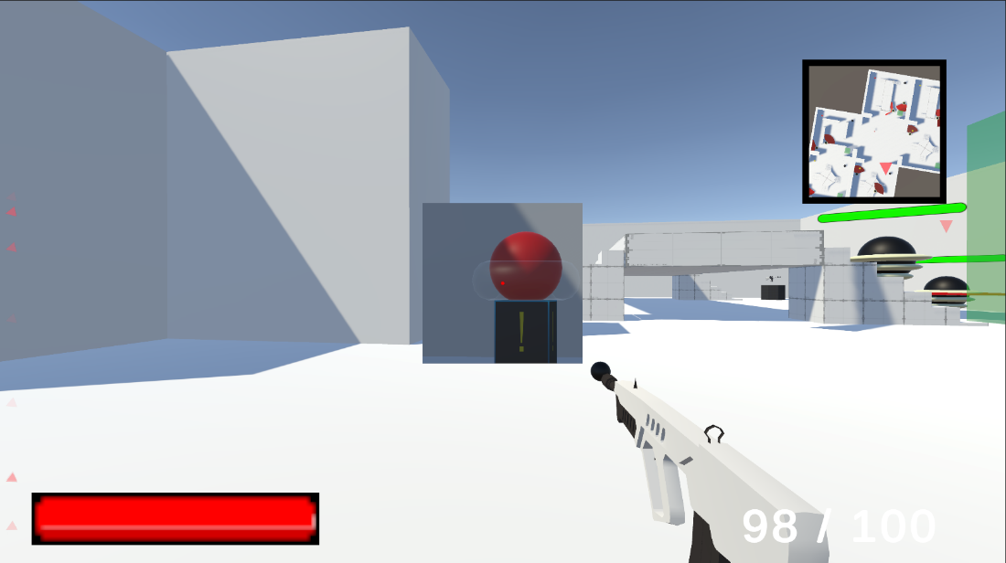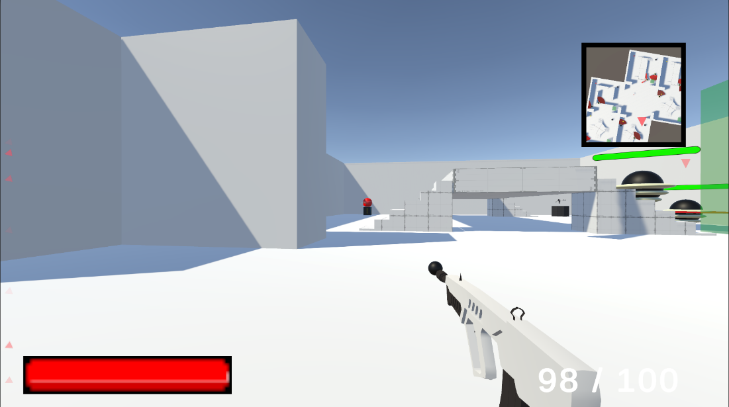

The magnifier can be used to focus on a particular area of the screen, increasing visibility and making it easier to view, as demonstrated above. This makes moving about the game environment simpler because it enables the player to see their next goal even when it is further away. With an eye tracker attached, the player can move it around the screen rather than being restricted to the middle of the screen, maximizing its utility.

**Audio Cue**

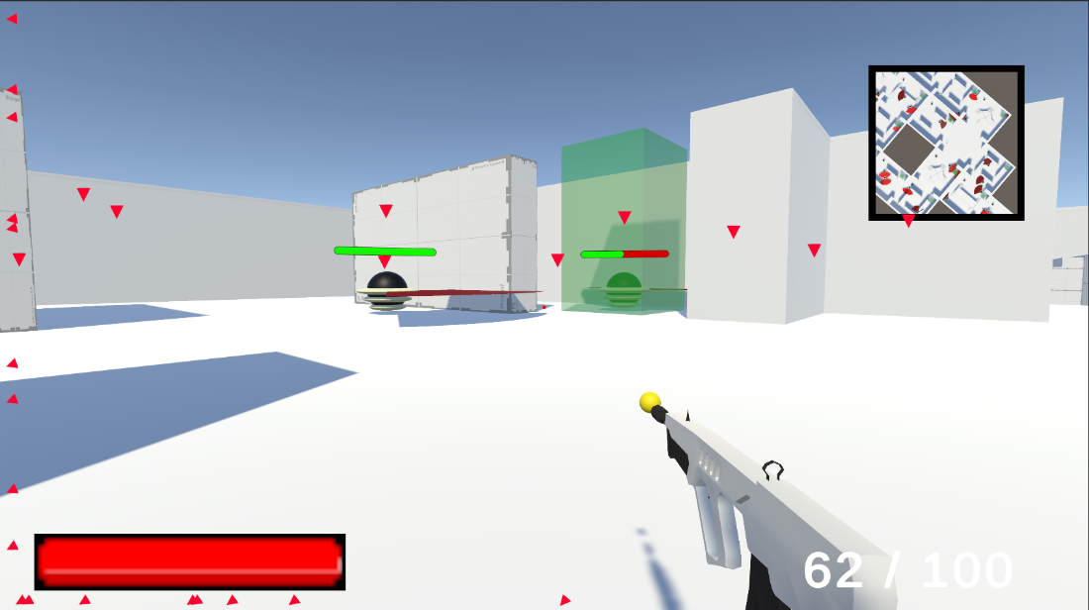

The arrows indicate where the enemies are depending on where the player is at and facing. The opacity of the arrows is used to represent the distance between the player and the enemy, with faded arrows indicating enemies that are further away. This feature is designed with the goal of providing an alternative means of identifying enemy positions for players with hearing impairments, allowing them to locate enemies without relying solely on auditory cues. By providing visual cues through arrows, players with hearing impairments can still effectively track enemy positions, even without direct visual contact with the enemies.

**Customizable Controls**

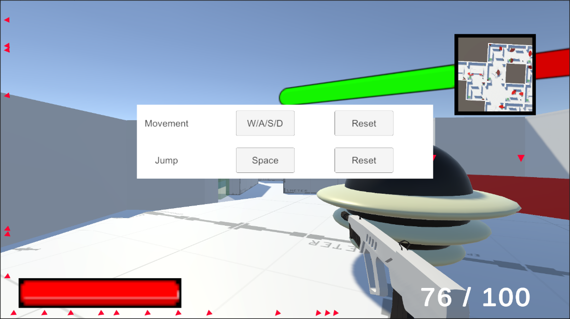

Players can rebind their controllers in the game's extensive custom controls option to better fit their unique demands. By using the escape key on the keyboard, which pauses the game and launches the custom controls menu, players can use this option. The controls for movement and jumping can then be remapped to the players' favourite keys or buttons. The custom controls option also allows gamers to connect their own controllers of choice, so it is not only confined to the keyboard. By allowing players with physical disabilities to use controls that are most comfortable and appropriate for their unique needs, this flexibility in control modification aims to lessen their physical discomfort and strain. By enabling players with physical limitations to participate completely in the gameplay experience on their own terms, this not only improves the immersion and enjoyment of the game but also encourages inclusivity.

**The questionnaire**

A questionnaire was designed with specific criteria which was sent out to players after they have finished their playtesting. The criteria are listed below:

**Visual cues**

To evaluate the effectiveness of visual cues in my game, I used the following guidelines as criteria: highlighting important objects, clear indicators for progress/objectives, and visual information for players with visual impairments. I included questions in my questionnaire that asked participants to rate the effectiveness of these visual cues on a scale of 1 to 5, where 1 represents "Not effective" and 5 represents "Very effective."

**Customizable controls**

To assess the customization options for controls in my game, I used the following guidelines as criteria: remapping buttons/keys, and alternative input methods for comfortable and effective control for players with diverse physical abilities. I included questions in my questionnaire that asked participants to rate the ease of use and effectiveness of these customization options on a scale of 1 to 5, where 1 represents "Very Easy" and 5 represents "Very Hard"

**Magnifier for zoom**

To evaluate the ease of use and benefit of the magnifier for zoom functionality in my game for players with visual impairments, I included questions in my questionnaire that asked participants to rate their experience with using the magnifier for zoom on a scale of 1 to 5, where 1 represents "not easy to use/ineffective" and 5 represents "highly easy to use/effective."

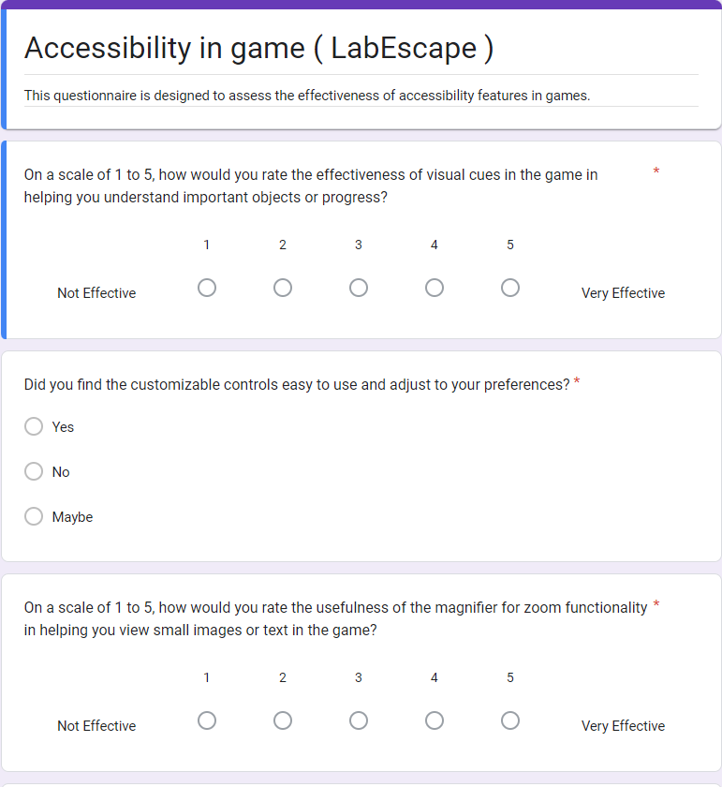

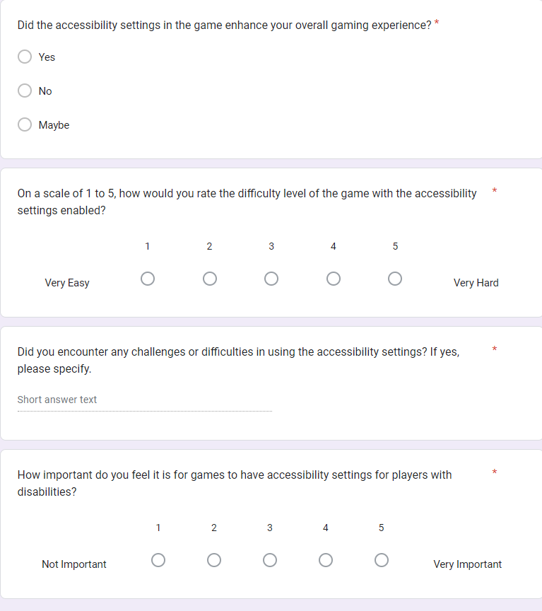

# Evaluation and Discussion

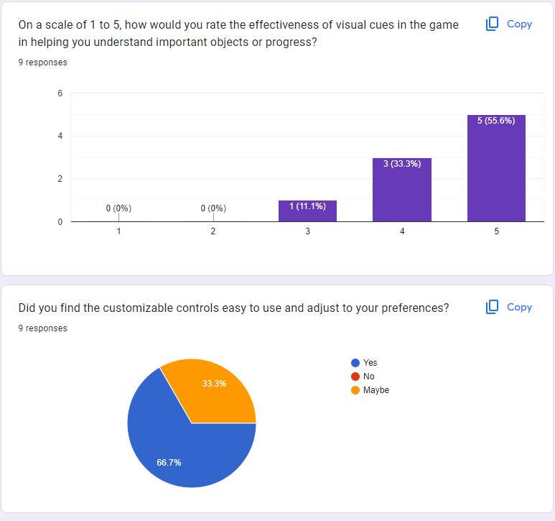

Based on the feedback gathered from participants, 5 out of 9 gave a rating of 5 showing that the visual cues were highly effective in helping them understand the importance of objects and progress. 3 out of 9 rated the effectiveness as 4, supporting the positive impact of the visual cues while only 1 participant rated it as 3. In conclusion, the findings indicate that the visual cues were positively received by most of the participants and can be considered as an effective accessibility.



Majority of the participants (6 out of 9) found that the customizable controls is easy to use and adjustable to their preferences, while the remainder responded with “Maybe”. This shows that most of the participants had a positive experience with the customizable controls, showing that they are generally effective in terms of accessibility and adaptability. More research is required to address the concerns of the participants who responded with uncertainty.

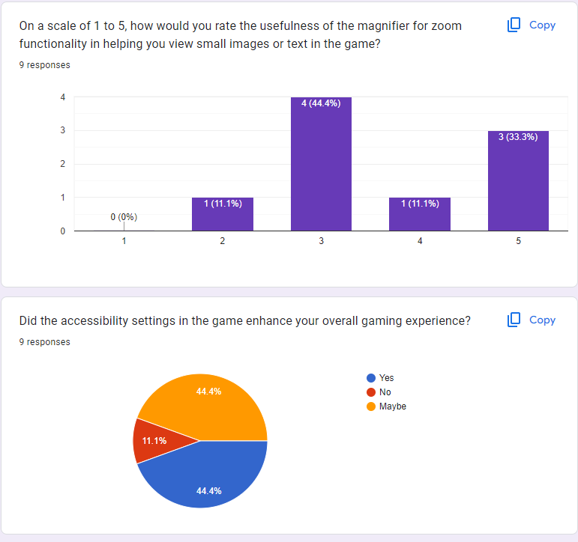

Based on the provided data, the majority of participants (4 out of 9) rated the usefulness of the magnifier to zoom in the game as 3, which is an average or indifferent opinion. 1 participant rated the effectiveness as 4 and 3 other participants rated it as 5 while 1 person rated it as 2. The results show a mixed of opinions among the participants and would require further research to get a conclusive finding on its usefulness.



Based on the given responses, 4 participants responded with ‘yes’ and 4 other participants responded with ‘maybe’ while 1 participant responded with ‘no’. 8 out of 9 participants either found the accessibility settings useful or indicated a possibility of finding them useful. This shows that the accessibility settings in the game have the potential to enhance the overall experience of playing the game.

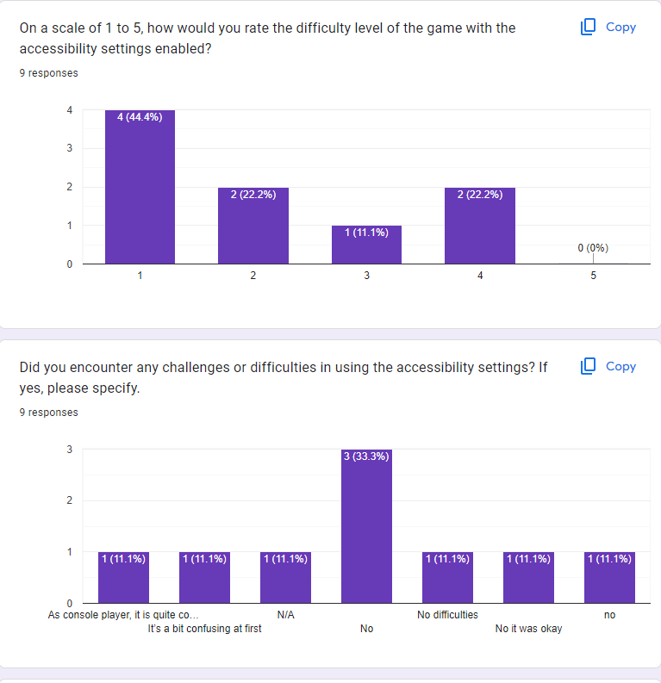

The difficulty level of the game was rated low by the majority (6 out of 9) of the participants with the accessibility settings enabled, indicating that the accessibility may have effectively reduce the difficulty level of the game for most of the participants. However, it was rated 4 by 2 other participants and 3 by 1 participant which suggest that the accessibility settings vary for different individuals.



Based on the graph, even with different answers, 7 out of 9 participants answered no, which show that most participants did not encounter any challenges or issue in using the accessibility settings. 2 out of 9 participants however mentioned that it was confusing for them.

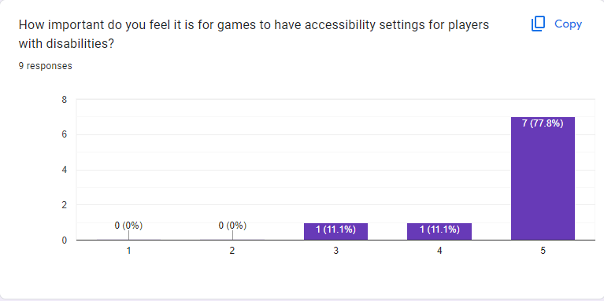‘

Based on the responses, the majority of participants (7 out of 9) rated the importance of accessibility settings for players with disabilities as very high. One participant rated it as 4 out of 5, and one participant rated it as 3 out of 5. This demonstrates that the majority of participants are aware of how important accessibility options are for disabled players. The overall finding indicates that most participants place a high value on accessibility settings, highlighting the necessity of inclusive design in gaming to accommodate a variety of demands and ensure a great gaming experience for all players.

**Major Technical Achievements**

**Eye Trackers**

This was my first time using an eye tracker, so it was initially daunting. Additionally, I only had access to the eye tracker for a short period of time near the end of my project, so I had to adapt quickly. Although Unity does not have a built-in library for eye tracking, I was able to request the SDK from the eye tracker website itself. When the eye tracker would not track my eyes properly, I kept getting error messages that I did not understand, but with the help of my classmates and some tutorials, I was able to get it working the way I wanted. With this progress, I was even able to add an additional feature where if the user closes one eye, it will zoom in or out depending on the eye that remains open.

**Procedural Dungeon Generation**

It was my first time working on a project that involved generating levels on the fly, and I saw it as a great opportunity to try out procedural generation, which has always fascinated me. After researching various methods, including checking for collisions, and using templates, I decided to use templates to create a series of rooms that would link with each other through doors. Once I understood how it worked, I took it a step further and implemented randomly generated obstacles. This way, even though the layout remained the same, the obstacles would be different, making it almost impossible to play the same level again. With the level randomly generated every time, the objective was also randomized, as players would need to clear a varying number of rooms depending on the size of the dungeon. This experience allowed me to explore the potential of procedural generation in creating dynamic and unique gameplay experiences

**Rebind Controls**

Unity has a built-in system that can automatically rebind keys for you, but it only works if you did not have a C# script for your inputs, which I did. I considered multiple ways to implement custom key bindings, and one approach I looked into was using the Command Design Pattern. This pattern involves encapsulating individual commands as objects that can be invoked at runtime to perform specific actions associated with the controls. It seemed like a good approach, but then I discovered that I could also write my own script. However, making the rebind script work at runtime for an input system that was built from the start didn't seem possible. I found multiple tutorials and tried several of them, but none of them worked for my project, except for one. I had to rewrite the code from the tutorial to fit my project, and it took almost a week to get it sorted out. But the result was worth it.

**Project Review**

**Document research**

The way I approach this project for the research was wrong as I was looking for specific research paper which can summarize everything I was looking for. I was looking for eye tracker in games which is very niche while I should be looking at eye tracker, accessibility in games, how disabled gamer overcome their limitation to play the game. These are some of the research papers I look at, but it takes me awhile to do my research as I was lost. After consulting with my supervisor, I realised my mistake and start looking for more research paper. The research takes a long time but as soon as I realized to not start looking for something as specific, the research become a lot easier, and I was able to progress.

After having my research done, my goal for the project was much clearer and from there the progress was smooth as I know what to do, however, I did face a couple of technical difficulties when I was coding the game.

**Magnifier in Unity**

There are multiple ways to create a magnifier in Unity. The first way I found was to make a shader graph however my skills in creating a shader are quite limited as we only work with shader multiple times in my third year. Creating a shader was complicated for me but I found a tutorial on how to do one. After multiple tries, it would come out as a pink shader which indicate there was something with the shader. The tutorial was old, so the shader does not work as some of the features only in the legacy version of Unity and no longer supported in the version I am working with. I also tried to do it myself with the logic of shader but to no avail.

The second steps were to simply lower the field of view of the camera which creates a zoom in effect. Problem with this method was that it zooms in the whole screen instead of just a part of the game which is what I want.

The last method that was unity new feature was that to put on a texture that represented what the camera is seeing on a game object and in my case, that would be a cube in front of the player. Even after finding out the method that works, I still need to recalculate how the view the camera is displaying is right view. To make it works with eye tracker, the camera rotation should update when the eyes is not looking at the middle of the screen. The calculations take me awhile as the magnifier would need to move vertically and horizontally in front of the player but not moving away or towards the player. This was hard to get my head wrapped around the idea as working in 3D, when the player is looking to the right, the magnifier x value would make the magnifier move away or towards the player instead of left and right.

After a lot of trial and calculation, it works out fine in the final version of the game. In the end, I make a secondary camera that would be attached slightly in front of the player and this camera would act as a magnifier so when the player moves, the camera view will be update as well.

**Sample size**

Due to time limitations, the playtest did not reach as many people as I want it to be. Some of the participants also did not have disabilities which was given limitation such as playing with no sounds and playing with only 1 hand to experience how it would be to play with these limitations. The questionnaire also could be improved to bring a more concise conclusion to my research. I do not have much experience on creating questionnaire so I would need to do more research on how to ask the right questions to get the answers that are more concise.

**More accessibility**

In the game I created, there are limited number of accessibility while there are more accessibility settings out there. The most famous was closed captions and subtitles which was not implemented in this game which can serve as another indicator so player would understand the goal more. There is also no audio cue to give some kind of hint to player who have visual impairments. The pacing of the game could also be too fast for player with cognitive impairments. Giving the ability to slow down the game pace would be a good addition.

**What could have been done**

If I can restart and do it again, I would treat the project as if it due the next month it was given out. I treated this project as how I treated my third-year project which was doing it when I have finished every other project and have some free time. I underestimated the research required for this project and how lost I was due to lack of research.

I would also try to make a viable version of the game as soon as possible and send it out for playtest and improve the game while waiting for feedbacks. The feedbacks could then serve as a guideline as how the accessibility or the game can be improved. Doing the playtest near the end did not give me enough time to react or implemented the feedbacks that I gathered.

**Advice for someone who are interested in doing this project**

I would advise to start as early as possible and make sure your goal is clear. Having multiple goals is bad as the point of your research can be in disarray and would confuse you halfway through the project. When starting your research, do not look for a specific research paper. For example, if your goal is about eye tracker used in video games, read about eye tracker, accessibility, and benefits of eye tracker, and draw your own conclusions as this would make you understand the topic much more clearly. Reading 1 paper about eye tracker would leave you with more questions at the end.

Start designing your game and implement the accessibility from the start as changing your game to implement these features could affect the flow of your game. It could also break some of your game features as it did with mine.

Take a calculated risk and try out new things as this is your opportunity to work on your own project rather than having some kind of guideline and requirements.

**Technologies used**

My technologies choice was perfect for me from the very start as I understood unity well as I have been working with unity for a year when I took on this project, however, there was still a lot that I learned throughout this whole project like the runtime navMesh and AI behaviour. It also uses C language which was a language I am most comfortable with. It allows me to quickly understand the tutorial I was watching and use it as a base for the features that I implemented.

Using GitHub as version controller was also a viable choice as most company use GitHub as their version control. Understanding how to push, what commits to write and when to push was extremely helpful in keeping my repository clean. It also allows me to quickly get in the flow once I read the commits message as I would know what I was doing even I left the project for a couple of days.

Eye tracker was new to me and did not necessarily help in the accessibility settings of the game. The result reflected this where most of the participants did not find it to be as useful as the others. However, eye trackers have always been fascinating to me as the idea of controlling or giving inputs with your eyes instead of your hand seems to me as a suitable alternative for people who has motor impairments.

# Conclusions

In conclusion, the findings indicate that the visual cues, customizable controls, and accessibility settings in the game were positively received by most participants and have the potential to enhance accessibility and adaptability. However, the magnifier received mixed opinions with most participants choosing 3 as their answers which indicate indifferent. The majority of participants recognized the importance of accessibility settings, highlighting the necessity of inclusive design in gaming.

Due to the limited number of participants in the study, resulting from time constraints and potential limitations of the questionnaire, further research is needed to address participant concerns and gather conclusive findings.

**Future Work**

There are more types of disability and accessibility out there that is not covered in this research paper that students can work on. One of the examples would cognitive disability and one accessibility for this would be the letting the player control the pacing of the game.

# References

Bei Yuan, E. F. (Apr 2, 2010). *Accessibility in game.* Retrieved from https://link.springer.com/article/10.1007/s10209-010-0189-5

Bureau, U. C. (2002). *Americans with disabilities.* Retrieved from https://avoiceformalestudents.com/wp-content/uploads/2013/08/Learning-Disabilities.pdf

Charlene Jennett a, A. L. (2008). *Measuring and defining the experience of immersion in games.* Retrieved from https://www.sciencedirect.com/science/article/pii/S1071581908000499

Dario Maggiorini, M. G. (2019). *Evolution of Game Controllers: Toward the Support of Gamers with Physical Disabilities.* Retrieved from https://air.unimi.it/bitstream/2434/685287/2/Maggiorini2019_Chapter_EvolutionOfGameControllersTowa.pdf

Denise N. Nogueira, F. R. (2012). *Analyzing the Use of Sounds in FPS games and its Impact for Hearing Impaired Users.* Retrieved from http://sbgames.org/sbgames2012/proceedings/papers/computacao/comp-full_16.pdf

Eyeware Beam . (2022). How Eye Tracking and Head Tracking Help Disabled Gamers Level Up. Retrieved from https://beam.eyeware.tech/disabled-gamers-level-up-head-eye-tracker/

Ferreiro, E. (2019). *EwOk, the World's Most Famous Deaf Professional Gamer.* . Retrieved from https://www.unusualverse.com/2019/09/ewok-videogame-deaf-fornite.html

Jen Beeston, C. P. (2018). *Accessible Player Experiences (APX): The Players.* Retrieved from https://link.springer.com/chapter/10.1007/978-3-319-94277-3_40

João Antunes, P. S. (2018, May 7). A Study on the Use of Eye Tracking to Adapt Gameplay and Procedural Content Generation in First-Person Shooter Games. Retrieved from https://www.mdpi.com/2414-4088/2/2/23/pdf

Jorge De Greef, V. P. (2018). Evaluating the Benefit of Assistive AR Technology through Eye Tracking in a Surgical Simulation System. Retrieved from https://lirias.kuleuven.be/retrieve/520081

Jovanovic, B. (2022). Gamer Demographics: Facts and Stats About the Most Popular Hobby in the World. Retrieved from https://dataprot.net/statistics/gamer-demographics/

Kate, F. (2022, 3 25). Gamer Born With No Hands Impresses Internet With Setup: 'Such a Boss'. Retrieved from https://www.newsweek.com/tiktok-reddit-86hands-martin-gaming-disability-accessibility-1691729#:~:text=A%20gamer%20has%20been%20praised,scenes%20videos%20of%20his%20gaming.

Kevin Bierre, J. C. (2005). *Game Not Over: Accessibility Issues in Video Games.* Retrieved from https://www.academia.edu/download/66556744/Game_Not_Over_Accessibility_Issues_in_Vi20210422-25571-pgoxva.pdf

Lucia Aiello. (2019). Digital Skill Evolution in an Industrial Relationship Professional Figure in Online Communities. Retrieved from https://www.igi-global.com/gateway/article/full-text-pdf/234350

Mark Brown, S. L. (2020). Designing for Disability: Evaluating the State of Accessibility Design in Video Games. Retrieved from https://journals.sagepub.com/doi/full/10.1177/1555412020971500?journalCode=gaca

Sennersten, C. (2004). Eye movements in an Action Game. Retrieved from https://lup.lub.lu.se/student-papers/record/1328850/file/1328851.pdf

Silman, J. (Sep 20, 2021). BrolyLegs on Video Game Accessibility: “We’ve Seen Progress, but Must Continue the Fight”. Retrieved from https://compete.playstation.com/en-ie/all/articles/brolylegs-on-video-game-accessibility-weve-seen-progress-but-must-continue-the-fight?filterNewsO=type.Guides&validatedAge=true

Tara Qadir Kaka Muhammad, H. O. (2022, April 4). Eye Tracking Technique for Controlling Computer Game Objects. Retrieved from http://65.21.159.25/index.php/uhdjst/article/view/903/683

Theodore Lim, B. N. (2011). *A Study of Raiders with Disabilities in World of Warcraft.* Retrieved from https://artifex.org/~bonnie/LIM_disabilites-26.pdf

Villanueva, J. (2019). *Fortnite player Ewok becomes the first female to join FaZe Clan*. Retrieved from https://dotesports.com/fortnite/news/ewok-becomes-the-first-female-to-join-faze-clan

Zalewski, D. (2021, November 4). Eye tracking and video games research. Retrieved from https://tryevidence.com/blog/eye-tracking-and-video-games-research/#:~:text=The%20eye%20tracking%20device%20emits,the%20screen%20player%20was%20looking

1.